Thursday

‘Welcome’ Snack Buffet
Appetizers and Assorted Sweets

Dinner
Tossed Green Salad and Seasonal Vegetables
Fettuccine Alfredo w/ Grilled Chicken
Meat and Cheese Lovers Lasagna
Garlic toasted Italian Bread
Selection of Desserts

Friday

Lunch
Southwest Fiesta:
Shredded Beef, Chicken Enchiladas
Black & Pinto Beans, Fresh Fixings
Corn & Flour Tortillas
Nachos, Grilled Corn, Mexican Rice
Tres Leches Cake

Dinner
Appetizers
Spinach and Strawberry Salad
Roast Beef, Baked Ham
Baked, Mashed or Rosemary Potatoes
Steamed Fresh Vegetables
Selection of Desserts

Saturday

Lunch
Seasonal Fruit
Fresh Salad and Soup
Variety of Meats & Cheeses
Fresh Toppings & Condiments
Specialty Breads and Rolls

Informal Dinner
‘Comfort Foods’ Buffet &
Selection of Desserts

Breakfast

Served Friday and Saturday

Bacon, Sausage or Sliced Ham
Belgian Waffles or Pancakes
Cheese Omelet or Quiche
Fresh Seasonal Fruits
Specialty Breads and Spreads
Variety of Hot & Cold Cereals
Assorted Juices, Milk and Hot Beverages

Sunday: Self-serve Continental Breakfast
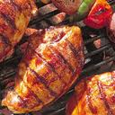
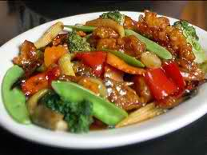
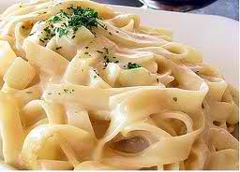
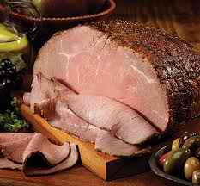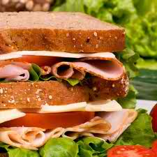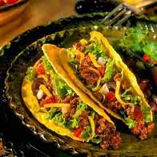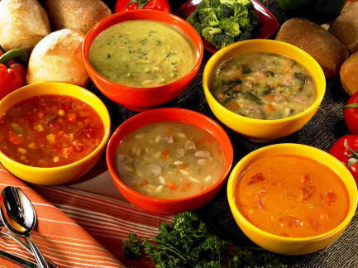



Meals will be served, buffet style:
Breakfast 7:30am - 9am
Lunch 1pm
Dinner 7pm

Snacks and Beverages provided throughout event

Menus are subject to change without notice.

*Please make us aware of special food requirements or allergies. We are happy to accommodate.

We are not licensed to serve alcoholic beverages.

